November Birthdays

1. Ann Chakales

Jessica Robbins

2 Bob Clarke

5 Christopher Palazzi

Donna Smith

6 Spencer Goolsby

7 Eleanor Elium

8 Karsen Burgess

9 Sylvia Glass

Jacob Powell

10 Elizabeth Ashworth

Charles Kitts

11 Casey Fish

12 Linda Mitchell

Charles Scott, Sr.

Harry White, III

13 Pat Moore

14 Kathleen Baker

16 Kelli Adams

John Martin, Jr.

Maggie Musgrove

17 Christian Barber

Frank Stewart

19 Ed Gibson, Jr.

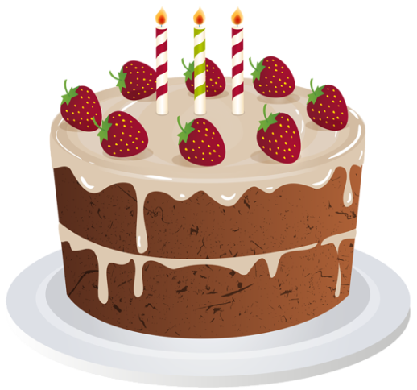21 Derrick Tedder

24 Ann Ruhland

Lee Steward

25 D’Lynn Burgess

Elizabeth Candler

26 Ella Dunn

28 Tad LeFew, III

29 Mary Mattox

Kim Scott

30 Carolyn Stewart

Phillip Yost